POTENTIAL ESSENTIAL OILS FROM GREEN BETEL LEAF (PIPER BETLE L.) AS A NATURAL PRESERVATIVE FOR MEAT FOOD

Elsa Dwi Ambarwati¹, Siti Nur Khafidhoh², Herlina Ayu Rachmanda³,
Naufal Khoirussyihab⁴, Princes Orinta Oktavia⁵, Endang Setyaningsih⁶
Universitas Muhammadiyah Surakarta, Indonesia
a420220051@student.ums.ac.id
Keywords | Abstract
Food Ingredients, Meat, Betel Leaves, Natural Preservatives. | Security food has become global attention, especially for a preservative experience to replace material chemistry. Oil essential oil leaf betel green (Piper betle L.) is a material experienced with eugenol, chavicol, and flavonoid content with characteristic antibacterial and antioxidant properties. Research This aims to study the effectiveness of oil essential oil leaf betel green as a preservative natural in meat products and determine the dose optimally. The experimental method uses a randomized block design (RBD) with four treatments: control and concentration of essential oil at 5 ml, 7.5 ml, and 10 ml. Observed parameters include pH, color, texture, and aroma of meat during seven-day storage, with data analysis using one-way ANOVA direction.  Research results show that oil essential oil leaf betel green effectively maintains quality meat, with pH stability and better organoleptic parameters than the control. Oil essential oil at a concentration of 7.5 ml and 10 ml provides results best in slow down decay meat until seven day. Implications study This is development material preservative natural friendly​ environmental and safe For industry food, at the same time reduce dependence on preservatives synthetic.
Corresponding Author: Elsa Dwi Ambarwati
Email: a420220051@student.ums.ac.id

INTRODUCTION
Security food is increasingly global challenges urgent, especially in the modern era with the world's population continues to grow increased. Problem This exacerbated by the use of material preservative synthetic in product food, which often causes concern to impact health term long (Andayani, 2014). Therefore that, search alternative experience For preservation food become very relevant. Oil essential from leaf betel green (Piper betle L.), which is rich in bioactive compounds, becoming one of the promising solution​ For the overcome challenge this (Christiani et al., 2023).
In context, Indonesia, with its abundant biodiversity, provides various material potential nature​ For development as a preservative natural. Betel leaf Green, for example, has long been known in practice traditional as agent antimicrobial. Content phenols and flavonoids give characteristic effective antibacterial​ To prevent damage to food, especially products based on meat (Riski, 2018). This becomes relevant. Remember, meat is one of the materials that is highly vulnerable food to contamination by microbes, which results in high water content (Dwiningrum et al., 2023).
Urgency study This lies in the need to find natural that are not only effective but also safe and friendly environment. Oil essential leaf betel green fulfil criteria This with various advantages, including ability hinder growth bacteria pathogen such as Staphylococcus aureus and increase age save food without cause risk toxic for consumers ( Nisyak & Haqqo , 2022).
Betel (Piper betle L.) is one of the medicinal plants that contains essential oils as its main characteristic. This essential oil consists of phenol compounds and phenol propylene derivatives, with eugenol (42.5%) as the main component. In addition, there are other compounds such as cavibetol, allilpirocatechol, carvacrol, chavicol, estragol, and sesquiterpene. Betel leaves also contain secondary metabolites such as organic acids, amino acids, sugars, vitamins, tannins, fats, starches, and carbohydrates that affect the quality (Handoyo, 2020).
Betel leaves (Piper betle L.) belong to the Piperaceae family and the genus Piper (Sarjani et al., 2017). Betel leaves contain 4.2% essential oils, which mostly consist of active compounds such as eugenol, cineol, and cavicol, which have antibacterial properties. These compounds are effective in inhibiting the growth of food spoilage bacteria, making betel leaves a natural preservative that can slow or delay spoilage in food products (Andayani et al., 2014). Green betel leaves contain phytochemical compounds such as tannins, saponins, flavonoids, alkaloids, terpenoids, steroids, and phenolics, which function as antimicrobials and antioxidants. Green betel leaf essential oil contains 4.2% essential oils, mainly eugenol, cineol, cavicol, and other compounds. The phenol and phenylpropanoid content in this essential oil has strong antibacterial and fungicidal properties ( Nisyak & Haqqo, 2022).
Research by Mentari et al. (2016) showed that betel leaf extract (Piper betle L) contains active compounds such as essential oils, tannins, flavonoids, and riboflavin, which have antifungal, antimicrobial, and antioxidant properties, effectively preventing the growth of spoilage bacteria in food. Betel leaves used for essential oil isolation come from the middle to the base of the stem, using a steam-water distillation technique to produce optimal essential oils without compound damage (Christiani et al., 2023).
Essential oils generally contain two groups of chemical components: Hydrocarbons and oxygenated hydrocarbons. In citronella oil, the main compounds, such as citronella, citronellol, and geraniol, have high economic value that can be increased through the manufacture of derivative compounds and standardization (Murni & Rustin, 2020).
Natural preservatives produced from natural ingredients are safe preservatives for preserving tofu. Natural ingredients that have the potential to be used as natural preservatives are betel leaf extract (Piper betle) and noni fruit (Morinda citrifolia), because they have antibacterial properties. Betel leaves (Piper betle L.) have health benefits such as treating wounds, toothache, and vaginal discharge. Noni fruit (Morinda citrifolia), in addition to being consumed, can be used for health, such as lowering high blood pressure, diabetes, and rheumatism (Pakpahan et al., 2015)
Food preservatives can be synthetic and natural preservatives (antimicrobials). The concentration of preservatives permitted by food regulations inhibits rather than kills contaminating organisms. According to the Regulation of the Minister of Health of the Republic of Indonesia Number 1168/MENKES/PER/X of 1999, there is a prohibition on the use of formalin as a food additive. Formalin is a toxic chemical that, when swallowed, will cause stomach irritation, nausea and vomiting, nerve and kidney damage, and even death (Kayaputri et al., 2017).
Food comes from plants and livestock, with livestock products being the main source of nutrients. Meat, which is rich in nutrients, is susceptible to contamination by microorganisms due to its high water activity (Aw) content. Preservatives such as sodium benzoate are needed to prevent contamination, but some producers in Indonesia still use prohibited preservatives such as borax in processed meat products (Dwiningrum et al., 2023).
The study of the potential of betel leaf extract (Piper betle L.) as a natural preservative for selar fish (Selaroides leptolepis) showed a significant effect on the concentration of 30%, with a Fcal value of 3.14 and an F Table of 2.85 at α = 0.05. 30% betel leaf extract effectively preserves selar fish in 32 hours. The hedonic test on fried selar fish also showed a significant effect on taste, aroma, color, and texture , so that hypothesis was accepted .
The study used a completely randomized design (CRD) using 5 treatments and 4 replications, namely T0 (unmarinated beef) and T1–T4 (soaked in garlic juice for 5, 10, 15, and 20 minutes at room temperature 25°C). As a result, marinating beef in garlic juice can reduce water content and total E. bacteria, but does not affect the pH value after 8 hours of storage at room temperature.
The administration of betel leaf extract at different levels had no significant effect (P>0.05) on the pH value of broiler chickens. The lowest pH value was found in P3 (6.18), which was lower than P0 (control). Although betel leaf extract is acidic because it contains carboxylic acids such as formic, acetic, and butyric acids (Indriastuti et al., 2012), its effect on the pH of chicken intestines is not statistically significant. Microbes thrive well at pH 6-7, while bacteria can grow at pH 4-7 (Putra & Ismanto , 2022).
Research by Miss Lia Mentari, Safrida, and Khairil (2016) showed that betel leaf extract with a concentration of 30% was able to preserve mackerel for 32 hours. Although the physical condition and freshness were not optimal, the fish was still suitable for consumption with organoleptic values of taste 5.65, aroma 5.1, color 5.5, and total 5.49, which were below the quality standard (SNI 01-2729.1-2006). Fish with 30% betel leaf extract had a freshness of 55.5% and remained suitable for consumption for up to 32 hours, while without extraction, its freshness only lasted up to 16 hours.
In our study entitled "Potential of Essential Oil from Green Betel Leaves (Piper betle L.) as a Natural Preservative for Meat Food Ingredients" due to the fact that betel leaf essential oil contains tannins, phenols, flavonoids, riboflavin, nicotine acid, so it can be used as a natural preservative. These components are able to prevent the presence of pathogenic bacteria in food that are known to spoil food. This study is slightly different from previous studies because it uses meat food samples for 7 days. The main objective study This For Analyze content chemistry oil essential leaf betel green that contributes to activity antibacterial and antioxidant. Evaluate effectiveness oil essential in extend age save meat. Develop method application oil optimal essential as preservative experience For product meat.

RESEARCH METHODS
Testing the potential of essential oils from betel leaves (Piper betle L) as a natural preservative for food ingredients was carried out using an experimental method. The research was conducted at the Biology Laboratory of the Muhammadiyah University of Surakarta. The research stages carried out were to find literature that was in accordance with the research to be carried out, then conduct field studies by making materials and starting the research. After that, data was taken from the samples to process the research data carried out.

RESULTS AND DISCUSSION
Research result show that the administration of betel leaf essential oil affects the quality of beef, goat, and chicken samples, with four treatments: control, concentrations of 5 ml, 7.5 ml, and 10 ml. The quality of the samples was assessed based on indicators of pH, color, texture, and aroma. Color was assessed with the criteria of brownish (1), pale white (2), pale brown (3), and yellowish (4); Texture was assessed based on the categories of fibrous (1), soft (2), slimy (3), and moldy (4); color with brownish (1), pale white (2), pale brown (3), and yellowish (4); Aroma with categories of no foul odor (1), slightly foul odor (2), foul odor (3), and very foul odor (4). Indicator 1 (pH), indicator 2 (Color), indicator 3 (texture), and indicator 4 (aroma). These indicators were used to measure changes in quality during the study.
Meat cow
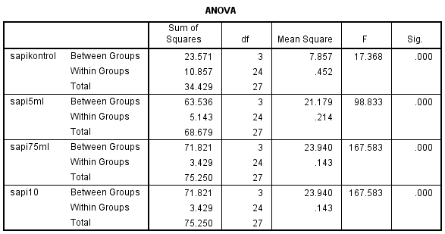
Tabel 1. Data Sampel Daging Sapi

Table 2. Results of Meat Sample Analysis Cow
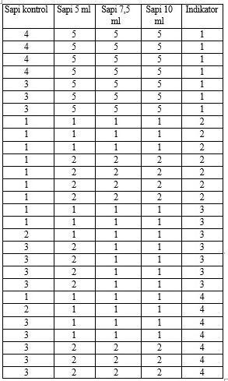

Based on Table 1, the initial pH control beef was 4 and dropped to 3 on the last day. Meanwhile, the pH of beef with concentrations of 5 ml, 7.5 ml, and 10 ml of betel leaf essential oil remained stable at 5 for 7 days. A pH below 6 allows microbial growth, where bacteria can thrive at pH 4-7 (Putra & Ismanto, 2022). Control beef was brownish throughout the study, while beef with betel leaf essential oil turned pale white on the fourth to seventh day. The texture of control beef changed from fibrous to soft and slimy in meat with essential oil, while in meat with essential oil, the texture remained fibrous until the seventh day for concentrations of 7.5 ml and 10 ml, and changed to soft at a concentration of 5 ml after the third day. The aroma of control beef began to smell bad on the second day, while in meat with essential oil, the bad smell only appeared on the fourth to seventh day. The results of the One Way ANOVA analysis on pH, color, texture, and aroma showed a significant effect (F > 0.05, p < 0.05), which indicates that the administration of betel leaf extract is effective as a natural preservative for beef at concentrations of 5 ml, 7.5 ml, and 10 ml for 7 days.
Lamb
Table 3. Goat Meat Sample Data
Tabel 4. Hasil Analisis Sampel Daging Kambing
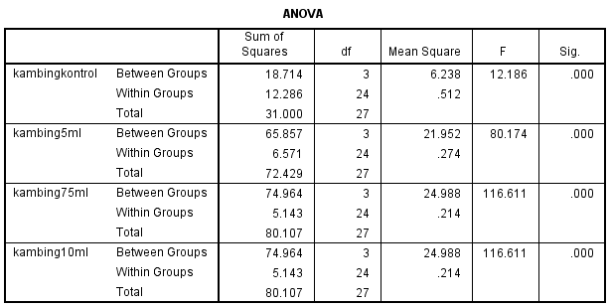
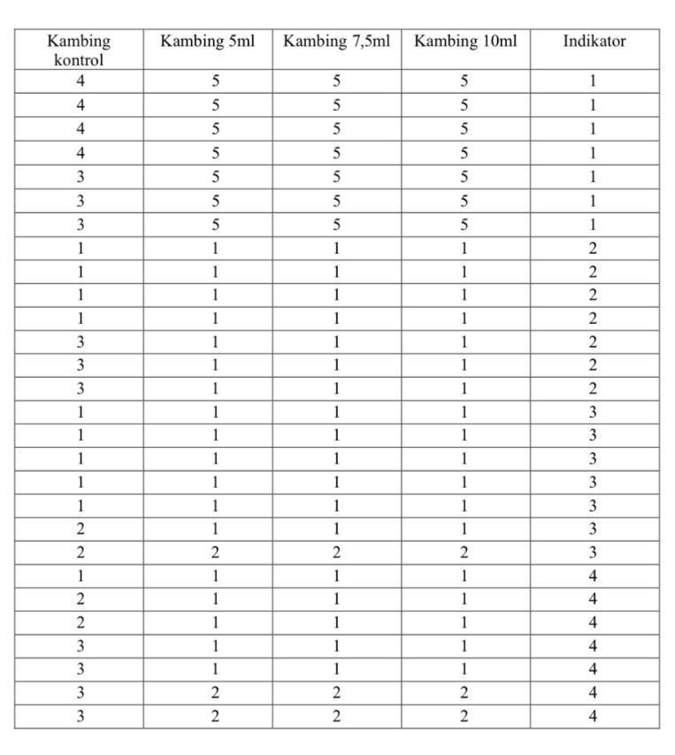

Based on Table 3, the initial pH control goat meat was 4 and decreased to 3 on the last day, while at concentrations of 5 ml, 7.5 ml, and 10 ml, the pH remained stable at 5. The color of the control goat meat changed from brownish to pale brown on the seventh day, while in meat with essential oils, the color remained brownish throughout the observation. The texture of the control meat changed from fibrous to soft on the sixth day, while in meat with essential oil concentrations, the texture remained fibrous until the seventh day, then became soft. The aroma of the control meat began to smell bad on the second day, while in meat with essential oils, the bad odor only appeared on the sixth to seventh days. The results of the One Way ANOVA test (Table 4.4) showed a significant effect (F> 0.05, p < 0.05), indicating that betel leaf extract was effective as a natural preservative for goat meat at concentrations of 5 ml, 7.5 ml, and 10 ml for 7 days.
Chicken
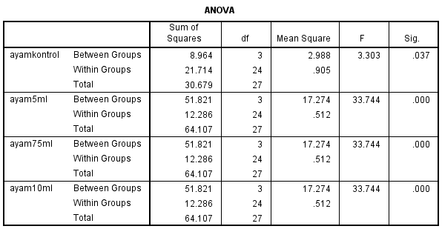
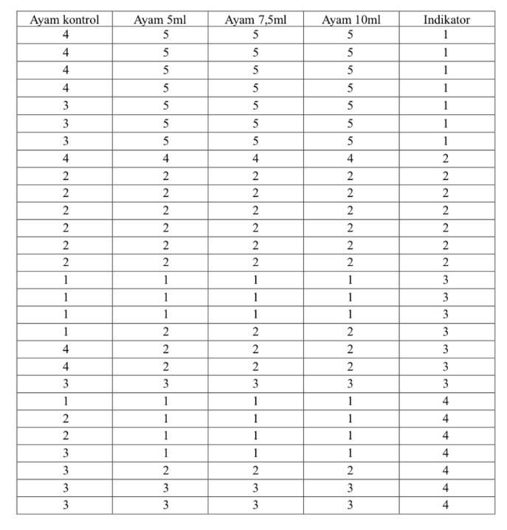
Tabel 6. Hasil Analisis Sampel Daging Ayam
Tabel 5. Daging ayam Sample Data

Based on Table 5, the pH of the meat control chicken was initially 4 and decreased to 3 on the seventh day, while at concentrations of 5 ml, 7 ml, and 10 ml, the pH remained at 5 from the beginning to the end. The color of the control chicken meat changed from yellowish on the first day to white on the second to sixth days, then pale white on the seventh day. At concentrations of 5 ml, 7.5 ml, and 10 ml, the color remained yellowish on the first day and pale white on the seventh day. The texture of the control chicken meat was fibrous on the first day and became soft from the fifth day, while at concentrations of 5 ml, 7.5 ml, and 10 ml, the texture was fibrous until the fourth day and became soft after that. The smell of the control chicken meat was odorless on the first day, slightly rotten from the second to third day, and rotten on the fourth to seventh day. At concentrations of betel leaf essential oil extract of 5 ml, 7.5 ml, and 10 ml, it was odorless until the fourth day, slightly rotten on the fifth day, and had a foul odor on the seventh.
Based on the results of the One Way ANOVA test (Table 6), there are significant effect on pH, color, texture, and aroma of chicken meat, with F value > 0.05 and significance < 0.05, indicating that H0 is rejected and H1 is accepted. Betel leaf extract is effective as a natural preservative for chicken meat at concentrations 5 ml, 7.5 ml, and 10 ml for 7 days.

Discussion
Research result show that oil essential oil leaf betel green (Piper betle L.) has significant potential​ as preservative experience For material food based on meat. This is reflected from ability oil essential oil in maintain quality physical and organoleptic meat cows, goats and chickens during storage. The parameters measured, including pH, color, texture, and aroma, provide indication that oil essential oil can hinder growth microbes rot (Putra & Ismanto, 2022).
Oil essential oil leaf betel green contain compound active such as eugenol, kavikol , and flavonoids which have characteristic antibacterial and antioxidant strong (Christiani et al., 2023). Activity antibacterial This in line with study previously which shows that extract leaf betel green effective hinder growth of Staphylococcus aureus, one of the bacteria pathogen main in product meat ( Nisyak & Haqqo , 2022). Compounds This capable bother membrane cell microbes , so that hinder metabolism and proliferation.
In the effectiveness test, the results show that the pH of the meat with treatment oil essential oil still stable during seven day storage, compared with control that is experiencing drastic pH drop. This pH stability important Because microorganisms rotten tend grows optimally at an increased acidic pH during the decomposition process ( Dwiningrum et al., 2023). On the other hand, the organoleptic parameters like color and texture also show that oil essential oil leaf betel green can maintain freshness meat longer.
Study This support findings previously that oil essential oil from plant Piperaceae effective used as preservative natural (Mentari et al., 2016). However, research This give Updates with apply oil essential oils in products meat during period more storage​ length. In addition , the method concentration tiered used​ in study This help determine optimal dose of oil essential oil For maintain quality meat without influence characteristics sensory such as taste and aroma (Hamidah et al., 2014).
In context sustainability , use oil essential oil leaf betel green as preservative natural also supports effort subtraction material chemistry synthetic in industry food . This is important remember global concerns about impact residue material preservative synthetic on health humans (Kayaputri et al., 2017). With Thus, oil essential oil leaf betel green No only give solution For problem technical, but also strengthens commitment to security more food​ healthy and friendly environment.

CONCLUSION
Oil essential oil This capable maintain quality physical and organoleptic meat , including pH, color, texture, and aroma, during storage until seven day. Compound active such as eugenol, kavikol, and flavonoids contained in oil essential oil give activity effective antibacterial and antioxidant​ in hinder growth microbes rotten. Application oil essential oil leaf betel green at concentrations of 5 ml, 7.5 ml, and 10 ml indicates results significant in guard pH stability and prolongation age save meat without influence characteristics organoleptic in a way negative.
Study This also provides contribution important in support use material natural friendly​ environment as replacement preservative synthetic at risk to health. With findings this, oil essential oil leaf betel green expected can become a safe and effective alternative For preservation food , at the same time support sustainability environment. Research advanced recommended For explore applications on various type product food other as well as to study effect term long its use on a scale industry.

REFERENCE
Andayani , T., Hendrawan , Y., & Yulianingsih , R. (2014). Oil essential leaf betel red (Piper crocatum) as anchovies preservative natural (Stolephorus indicus). Journal Bioprocessing Commodity Tropics , 2(2), 123–130.
Aulawi , RM (2016). The Influence Additions Betel Leaf Microcapsules (Piper betle L.) against Quality Meat Cows . Thesis , Sunan Kalijaga State Islamic University of Yogyakarta.
Christiani, GJ, Rawar, EA, & Yuhara , NA (2023). Determination Activity Antioxidants with DPPH Method and Content Total Phenol in Oil Green Peel Leaves Essential Oil Determination of Antioxidant Activity by DPPH Method and Total Phenolic Content in Green Peel Leaves Essential Oil. 10(2), 79–85. https://doi.org/10.33508/jfst.v10i2.4893
Dwiningrum , R., Pisacha , I.M., & Nursoleha , E. (2023). Review : Analysis Qualitative and Quantitative Protein Content in Food Ingredients Processed Aisyah Journal of Pharmacy, 2(2), 60–67.
Hamidah, T., Kumalaningsih , S., & Dewi, IA (2014). Manufacturing Green Betel Leaf Oleoresin Extract (Piper betle L.) as Natural Preservatives ( Temperature and Extraction Time Study ). Journal Technology Agriculture , Brawijaya University .
Handoyo , DLY (2020). The Effect of the Length of Maceration Time ( Soaking ) on Viscosity Landa Leaf Extract. Tinctura Pharmaceutical Journal, 2(1), 34–41. https://doi.org/10.35316/tinctura.v2i1.1546
Kayaputri , I.., Cahyana , Y., Rialita , T., Sumanti , DM, & Pratiwi, SM (2017). Strategy for Using Natural Preservative Extract Skin Cocoa Beans . Journal Science and Technology Applications for Society, 6(2), 116–119.
Mentari, NL, Safrida , & Khairil . (2016). Potential Giving Betel Leaf Extract (Piper betle L) as Natural Preservative for Selar Fish ( Selaroides leptolepis ). Journal Scientific Biology Education Student , 1(1).
Murni, & Rustin, L. (2020). Characteristics Contents Oil Essential Oil Lemongrass Plant (Cymbopogon nardus L.). Journal of UIN Alauddin Makassar, September, 227–231. http://journal.uin-alauddin.ac.id/index.php/psb/
Nisyak , K., & Haqqo , A. (2022). Activity Antibacterial Extract Ethanol and Oil Essential Bingih Hijau against Methicillin- Resistant Staphylococcus aureus. Journal Anwar Medika Pharmaceutical Care (J- PhAM ), 5(1), 1–14.
Pakpahan , R.A., Khotimah , S., & Lobak , M. (2015). Effectiveness Extract Ethanol from Betel Leaves (Piper betle L.) and Fruit Noni ( Morinda citrifolia L.) As alternative preservative know . Protobion , 4(1), 115–119.
Putra, AS, & Ismanto , A. (2022). The Influence soaking chicken intestines with extract leaf betel (Piper betle L.) against quality physical , organoleptic and total bacteria . Journal Farm Environment Tropics , 5(1), 9. https://doi.org/10.30872/jpltrop.v5i1.6057.
Putri, PM (2013). Green Betel Leaf Extraction Results (Piper betle L.) as Natural Preservatives in Meatballs Cows. Thesis , Brawijaya University.
Riski, S. (2018). Physicochemical and Organoleptic Quality Precooked Chicken Meat with Betel Leaf Juice (Piper betle L.) at Concentration and Age Save Different . Journal​ Science and Technology of Animal Products .
Sarjani, TM, Mawardi, M., Pandia, ES, & Wulandari, D. (2017). Identification Morphology and Anatomy of Stomata Family Types Piperaceae in Langsa City. Journal of Science & Science Learning , 1(2), 182–191. https://doi.org/10.24815/jipi.v1i2.9693.
Sirait, Y. (2015). Utilization Green Betel Leaf Extract as Natural Preservatives in Fresh Chicken Meat. Thesis, Samarinda State Polytechnic.

